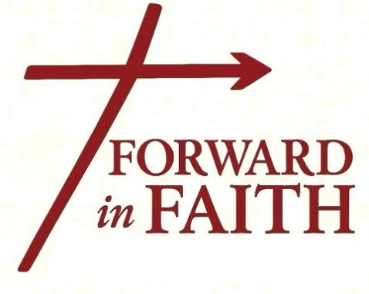
ADULT FAITH
Enrichment

Opening Your Heart Bible Study  Monday, 10:00 am-11:30am  Coming in October!  Room TBA  CHILDCARE PROVIDED  Contact: pawelek.judy7@gmail.com or  turk.katy@gmail.com | Portrait of the First American Pope & The Chosen Study  Wednesday, 3:00pm-5:30pm  September 10-November 19  Room 207  Contact: Cathy Sondergaard  cathy@sondy.us
Divine Mercy (Bilingual)  Monday, 5:30pm-6:30pm  Weekly  Room 204  Contact: Courtney Schonefeld  courtneyschonefeld@hotmail.com | A Journey Through the Catechism of the Catholic Church-Ascension  Wednesday, 6:30pm-8:30pm  September 4-March 4  Room 207  Contact: Steve Strickland  steve_731@hotmail.com
Lectio: The Case for Jesus  Tuesday, 10:00am-12:00pm  September 23-November 18  Parish Hall  Contact: Sharron Petri  skpetri@yahoo.com | The Nicene Creed  Thursday, 10:00am-12:00pm  September 18-December 18  Room 207  Contact: Mary LaFond  maryandgang@gmail.com
Endow Study: St. Teresa of Avila  Tuesday, 6:00pm-7:30pm  September 9-October 28  Room 207  Contact: Stephanie Chamberlain  sabshire@gvtc.com | Discernment of Spirits – Dan Burke  Thursday, 6:30pm-8:00pm  September 18-October 23  Room 207  Contact: Carolyn Denny  carolynd@gvtc.com
Early Church History & The Nicene Creed
Tuesday, 7:00pm-8:30pm
September 9-October 28
Room 206
Contact: Kate Chiodo
kate@chiodo.net

